2.2.16
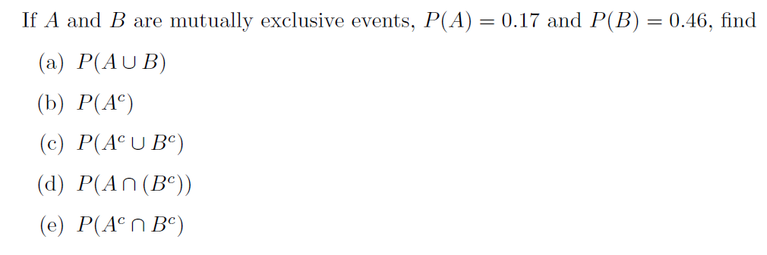
Solution

2.2.21

